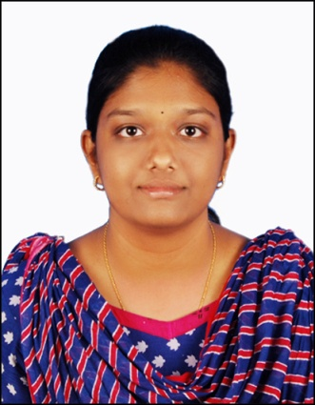
Ms. S.KEERTHANA PROFILE

Ms. S.Keerthana
Assistant Professor,
Department Of Biotechnology
Periyar Maniammai Institute of Science
And Technology (Deemed To Be University)
Thanjavur-613 403.
Email Id:keerthanas@pmu.edu.

Educational qualification:
Education qualification | - M.Tech –Biotechnology, 2021, Kumaraguru college of Technology, Coimbatore.  - B.Tech-Biotechnology, 2018, Periyar Maniammai institute of science and technology, Thanjavur.
Teaching Experience | - Working as assistant professor from 16.08.21 to till date
Area of interest | - Genetics  - Molecular biology  - Microbiology  - Plant biotechnology  - Drug delivery
Papers Published | - Comparative study of enzyme hydrolysis and chemical hydrolysis for bioethanol production from bagasse in International Journal for Innovation Research in Multidisciplinary Field.  - In Silico Screening of Antimicrobial Compounds Using Docked Complexes of Antibiotics and Antimicrobial Peptides in Bioscience Biotechnology Research Communications.
Area of specialization | - Transdermal drug delivery system  - Antimicrobial peptide screening
Workshops and conferences | - Attended workshop on Interpretation of spectral, chromatographic, crystallographic and computational date of chemical system jointly organized by PRIST university and Institute of crop processing technology, ministry of food processing industries, government of India-Thanjavur.  - Attended workshop on Bioinformatics tools and techniques organized by biotechnology researchers and innovators consortium (BRIC), Department of biotechnology, Periyar maniammai university, Vallam, Thanjavur.  - Attended workshop on National level CME cum seminar on Basics of immunology and it’s clinical applications jointly organized by school of biotechnology – Madurai Kamaraj university, Indian immunology society, DBT, Immunology foundation, Indian national academy.
Projects | - Identification of Antimicrobial compounds Targeting pilin subunits  - Synthesis and characterization of Naringenin loaded transfersomes Gel for Topical application for Breast Cancer and Isolation of proteins from salivary glands of AEDES AEGYPTI - An attempt for an early detection of dengue.
Training experiences | - various clinical biochemistry, Microbiology, Hematology and serology techniques at - bioline laboratory Coimbatore-Tamilnadu in 2015.  - Training on Anti-inflammatory drug using natural sources (brassica oleracea leaf) at Corx live science and pharmaceutical laboratory (CLAP)-Trichy -Tamilnadu in 2016.  - training on Food quality analysis at Indian institute of food processing technology ministry of food processing industries, government of Indian-Thanjavur-Tamilnadu in 2017

